**47th Australasian Fire Brigades Golf Championships**

**Emerald Lakes Golf Club**

**Sunday 10th November 2024– Friday 15th November 2024**

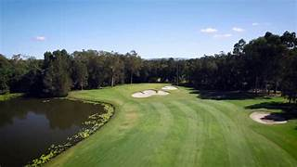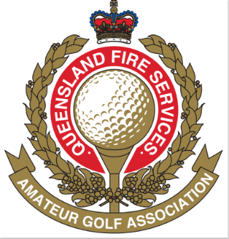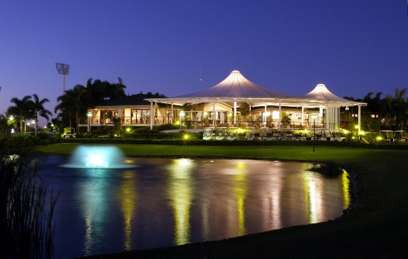

**SCHEDULE OF EVENTS**

**Sunday 10th**

WELCOME NIGHT AT EMERALD LAKES GOLF CLUB

**Monday 11th**

PRACTICE ROUND AT EMERALD LAKES GOLF CLUB

**Tuesday 12th**

1ST ROUND OF CHAMPIONSHIP AT EMERALD LAKES GOLF CLUB

**Wednesday 13th**

2ND ROUND OF CHAMPIONSHIP AT EMERALD LAKES GOLF CLUB

**Thursday 14th**

REST DAY – A CHANCE FOR YOU TO EXPLORE THE GOLD COAST AT YOUR LEISURE

**Friday 15th**

SPONSORS’ AMBROSE DAY AT A PREMIUM GOLD COAST GOLF COURSE TBA

**Friday 15th Evening**

PRESENTATION DINNER AT THE MERCURE PALM MEADOWS

Partners’ trips will be advised when the nominations forms are sent out

**PREFERRED ACCOMMODATION FOR EASE OF PICK UP TO EMERALD LAKES GOLF COURSE**

**MERITON BROADBEACH** – 2669 GOLD COAST HIGHWAY, BROADBEACH

**Phone**: 07 5579 6200

**MERCURE GOLD COAST RESORT** – 64 PALM MEADOWS DRIVE, CARRARA

**Phone:** 07 5555 7700

**RACV ROYAL PINES RESORT** – ROSS STREET, BENOWA

**Phone:** 07 5597 8700

**STAR GOLD COAST**  - 1 CASINO DRIVE, BROADBEACH

**Phone:** 07 5592 8100

Discount Codes for most of these locations will be forwarded to your

State Secretaries in the coming months.

These are the locations where you will need to be picked up from due to increased traffic congestion on the Gold Coast.

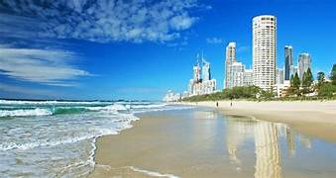

Look forward to seeing you all at the beautiful Gold Coast next November.

Any enquiries please contact:

Stephen Gooding – 0403 433 507

Frank Stemm – 0419 667 284