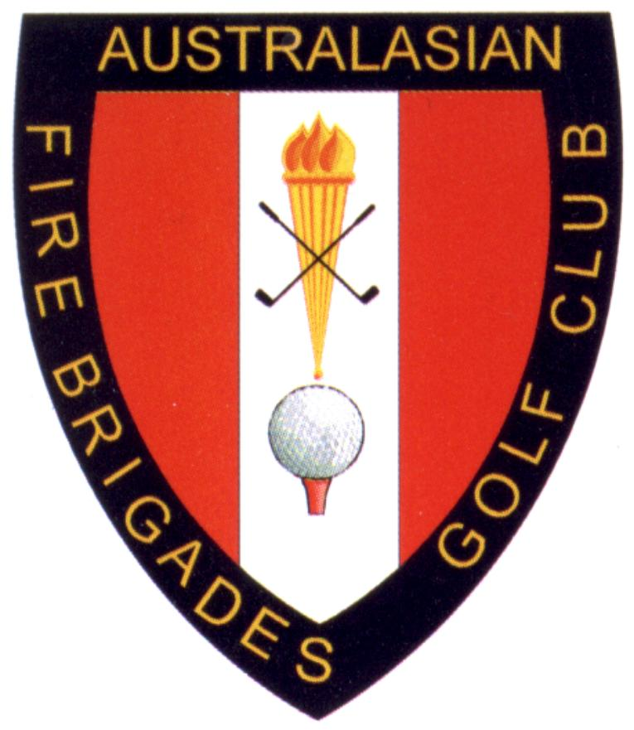

Partner Registration

PBI 47th Australasian Fire Brigades Golf Championships Gold Coast 10th – 15th November 2024

|  |  |  |  |
| --- | --- | --- | --- |
| Surname: |  | First Name: | Preferred Name: |
|  |  |  |  |
| Home State: | Email: |  | Phone: |
| Partner: |  |  |  |

**Accommodation Details**

Staying At: Sharing With: (List all Names)

**Travel Details**

Airport of arrival:

Mode of transport:

Hire car / train / personal car

Flight #:

Arrival Date:

Arrival Time:

Departure Date:

Flight Time:

**Weeks Activities**

|  |  |  |  |
| --- | --- | --- | --- |
| Sunday 10th Nov | Welcome Night at Emerald Lakes Golf Club | $75.00 |  |
| Monday 11th Nov | Free to see the sigghts |  |  |
| Tuesday 12th Nov | Bus Trip to Gallery Walk Tamborine Mountain  with Lunch at St Bernards | $60.00 |  |
| Wednesday 13th Nov | Come and cruise the canals of the Gold Coast with Lunch | $65.00 |  |
| Thursday 14th Nov | Rest Day – Take your pick on what the GC has to offer |  |  |
| Friday 15th Nov | Free to see the sights and prepare for presentation Night |  |  |
| Friday 15th Nov | Presentation Night at Q1 Skypoint Surfers Paradise | $135.00 |  |
| Transport/Registration | Transport for the week | $40.00 | $40.00 |
|  | **Note all rounds of Golf include motorised carts** | **TOTAL** |  |

* Completed forms along with payment should be sent to your State/Territory Secretary prior to the closing date of nominations.
* Secretaries to collate nomination forms and forward the completed attached spreadsheet to the following address by the **9th Aug 2024**
* **qldfiregolf@gmail.com**
* Due date for payments will be **9Th Aug 2024**
* Preferred payment via bank transfer

Account name : QFSAGA S.Gooding

BSB:124 001 Account Number : 22898188

* Travel details – note if your Flight is arriving from interstate or internationally (NZ) into Gold Coast or Brisbane there is no transfer by QFSAGA available to accommodation for the week.
* Transport to the course/return each round will be from pick up points in Broadbeach and other preferred accom will be advised closer to the tournament.
* **Options** – car hire approximately - 1 hours from Brisbane or 40min from the Gold Coast.
* Travel by Air train from Brisbane to the Gold Coast. (Light rail runs from Helensvale to Broadbeach.)
* Use Con-X-ion airport transfer from either Airport. This link will give discount <http://www.con-x-ion.com/Pages/ConferenceTransfers.aspx?pid=AFBGT24>